**CHAPTER 1**

**INTRODUCTION**

**1.1 OVERVIEW**

Traditional earlier systems for book tracking in the library make use of static desktop computing with database systems that only had the classification call numbers of the books rather than providing any more guidance to users for services and spatial awareness. Owing to this fact, many constraints become more apparent, students might be confused about the location of the resources and their own location after querying in the library system until he/she ask to the librarian staff to look up the shelf numbers or by doing manually by searching each shelf by his own, of course this is time-consuming. But the fact is that not every user will ask about how to use and search for material; it was found that 75 to 85 percent of students using library with research purposes described in terms of fear and confusion their initial response to library research. Augmented reality is a relatively new field of technology, only recent years it has become so popular on account of new development platforms. Augmented Reality (AR) is one of the most promising contemporary technologies that has the potential to utterly change how people react with the real world, practically transforming reality to an enhanced digital environment full of interesting and useful information. Augmented reality like most of established technologies can be used in every field of day-to-day life. The attraction of augmented reality is its simplicity

* 1. **PROBLEM DEFINITION**

Many libraries make use of passive and fixed signs, such as floor plans and call numbers, in order to bring some guidance to the users. However, these indications are not fully functional since they do not provide personal aid for students that requires a specific material or service nor for newcomers that might be confused about their own location while looking for resources at the library. Although there exist a number of augmented reality applications specially designed for the users of libraries, their number is limited. None of them got ready for the market and some of them, even discontinued. This might be due to an immature technology, financial issues, a lack of acceptance among users or a lack of acceptance among librarians. To identify the potential of augmented reality apps in libraries we will focus on the point of view of libraries. To create an interactive library management system that can be used make library more appealing. AR offers a strategic medium through which librarians can attach additional digital information to real-world objects and simply let users interact with them. This application can reduce the complexity of managing a library.

**CHAPTER 2 LITERATURE SURVEY**

**1.** **Spatial Augmented Reality Based Customer Satisfaction Enhancement and Monitoring System, Udaya Dampage, D.A.Egodagamage,2021[6]**

The SAR technology mostly uses 3D visualization, which attempts to show by projecting 3D information onto a 2D plane. The perception of the quality of food was enhanced by the recreation of the live environment on the preparation of the menu ordered, utilizing the waiting time after each ordering session. The dishes are being portrayed in three-dimensional (3D) virtual menu also, adding SAR features in a special angle creating a 3D illusion to the naked eye.

**2. Virtual reality and augmented reality in social learning spaces: a literature review, Ali Arya, Robert J. Teather,2020[7]**

This literature review is a broad and qualitative overview of the use of VR and AR within a social education context, serving as an entry point into a discussion and more sophisticated analysis into the present and near-future of VR/AR in learning. To minimize the size and scope of a paper with such an overwhelming amount of literature on this subject we focused on building upon prior surveys.

**3. Rendering Optimization for Mobile Web 3D Based on Animation Data Separation and On-Demand Loading, Liang Li , Xiuquan Qiao , Pei Ren,2020[8]**

Augmented Reality (AR) and Virtual Reality (VR) technologies, this 3D model interaction technology has received widespread attention from academia and industry as a primary enabling technology. Web based 3D applications in browsers are portable and versatile, providing the foundation for sharing 3D information across platforms.

**4. 3D model interaction, Shabnam Shahreen Sifat and Ali Shihab Sabbir,2019[9]**

A new type of information interaction mode, provides a more intuitive and efficient means of information presentation than the 2D plane method. Augmented Reality (AR) and Virtual Reality (VR) technologies, this 3D model interaction technology has received widespread attention from academia and industry as a primary enabling technology.

**5. Active Visitor: Augmenting Libraries into Social Spaces, Zois Koukopoulos, Dimitrios Koukopoulos,2019[10]**

This present Active Visitor, a system that offers engaging, personalized and immersive social and AR services to library visitors aiming at the optimization of user experience during a library visit, prolonging the visit’s time and the personalization of book reading. Library visitors can use those services through their personal smartphones by simply installing the library’s dedicated mobile application minimizing the cost of technological equipment for the library. Offering interesting, useful, user-friendly and engaging services to library visitors is a bet that every library should win. Libraries should be open-minded to adopt new technologies like AR and adapt them to the special characteristics a library environment demonstrates.

**6. A Mobile Intelligent Training System for ATM. Yongjun Qiao , Xiaofang Xie , Tao Sun,2018[11]**

This literature is based on 3D application solutions require users to download and install applications, and because of the limitations of portability, cross-platform operation and information

**7.** **Mobile Augmented Reality Survey: From Where We Are to Where We Go, Dimitris Chatzopoulos, Carlos Bermejo, Zhanpeng Huang, And Pan Hui,2017[12]**

By considering all the definitions from various researchers in the past , we can conclude that MAR:

1) combines real and virtual objects in a real environment,

2) is interactive in real time,

3) registers and aligns real and virtual objects with each other, and

4) runs and/or displays the augmented view on a mobile device.

Any system with all above characteristics can be regarded as a MAR system.

**8. The Augmented Library: An Approach for Improving Users Awareness in a Campus Library,** **Albert A. Cervera-Uribe,2017[13]**

Show the location of the main services and book shelfs of the library through the use of a 3D augmented reality indoor map. Provide an AR shelf searching system (ARSSS) which enables users to navigate and search for material.

**CHAPTER 3**

**SYSTEM ANALYSIS**

**3.1 EXISTING SYSTEM**

In the existing system the conventional libraries are less interactive with the students. Though the stack contains stickers it is difficult to navigate through the stacks and to find the right section. Similarly, some of the libraries are digitized but they are accessible from systems that are available inside the library. And also the number of systems available are very less that results in reduced accessibility. Accessing the library from digital world is difficult and also it is not more user friendly. To overcome these drawbacks, we have proposed an application using augmented Reality (AR).

**3.2 PROPOSED SYSTEM**

Most Augmented Reality apps in libraries are in the research and development phase though they represent a profound opportunity for increased access to print and digital library collections. AR applications can yield an engaging and interactive information experience. Applications that overlay graphical data are well suited for in-library engagement as well as off-site real-world interaction with library content. Mobile augmented reality applications offer much for the integration of library resources into users’ information environment. Libraries, through further research and development efforts, can continue to expand and extend the library presence in this environment through augmented reality applications.

**3.3 FEASIBILITY STUDY**

**TECHNICAL FEASIBILITY**

* **Unity 3D**-It is a cross platform game engine used to build real time 3D projects. It features a huge 3D creation features and is able to support Vuforia so that it can implement augmented reality application much easier and faster. It is processed in C# language.
* **Vuforia**-It is a software development kit (SDK) used for creating augment reality apps Vuforia cloud recognition service is an enterprise class image recognition solution that enables developers to host and manage image targets.
* **Android Studio-**It is a scripting software which can be connected with unity 3D to build and run android app.

**SOCIAL FEASIBILITY**

* This paper proposes an Augmented Reality (AR) based application which aims to solve users spatial unawareness at library by providing an AR shelf searching system, and to assist students and newcomers by providing a mobile guide with library information services into library.
* Combines real and virtual.
* Interactive in real time.
* Registered in 3D.

**ECONOMICAL FEASIBILITY**

* This Project is carried out to check the economic impact that the system will have on the Library Management.
* The amount of fund that the company can pour into the research and development of the system is limited.
* The expenditures must be justified. Thus, the developed system is within the budget and this was achieved because most of the technologies used are freely available. Only the customized products had to be purchased.

**3.4 HARDWARE ENVIRONMENT**

* Android Mobile.
* Processor-Intel®Core™i3-6006U [CPU @2.00GHz](mailto:CPU@2.00GHz), 4 GB RAM,
* NVIDIA GeForce MX330

**3.5 SOFTWARE ENVIRONMENT**

* Unity 3D
* Vuforia
* Android Studio

**CHAPTER 4**

**SYSTEM DESIGN**

**4.1 ER DIAGRAM**

An **entity relationship diagram** (**ERD**) shows the relationships of entity sets stored in a database. By defining the entities, their attributes, and showing the relationships between them, an ER Diagram illustrates the logical structure of databases.ER Diagrams are used to sketch out the design of a database.

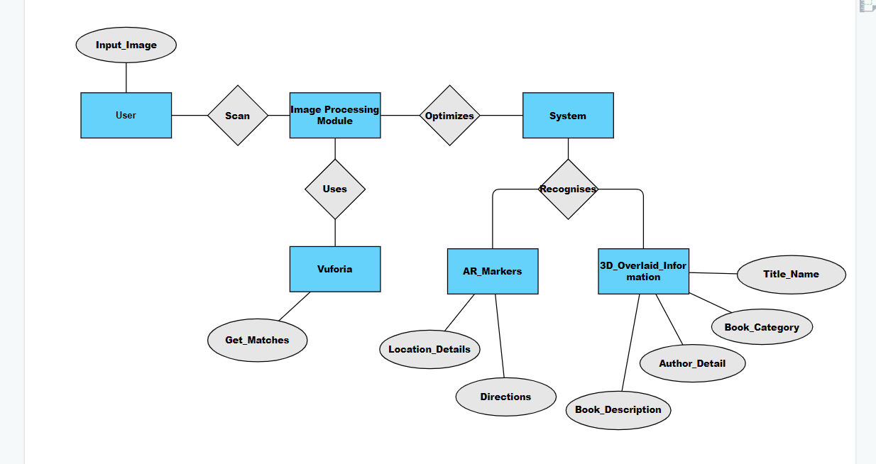

Figure 4.1 – Entity Diagram of AR Library Project

**4.2 DATA DICTIONARY**

The Data that we have used here are Target Images. Where, Information is retrieved from the database in according to the marker recognized. The Input frame and the output frame is integrated into a single frame thus making the real world be augmented by the virtual world.

**4.2.1** **IMAGE DATASETS**



Figure 4.2.1 – The Target Image for the Category under Fiction

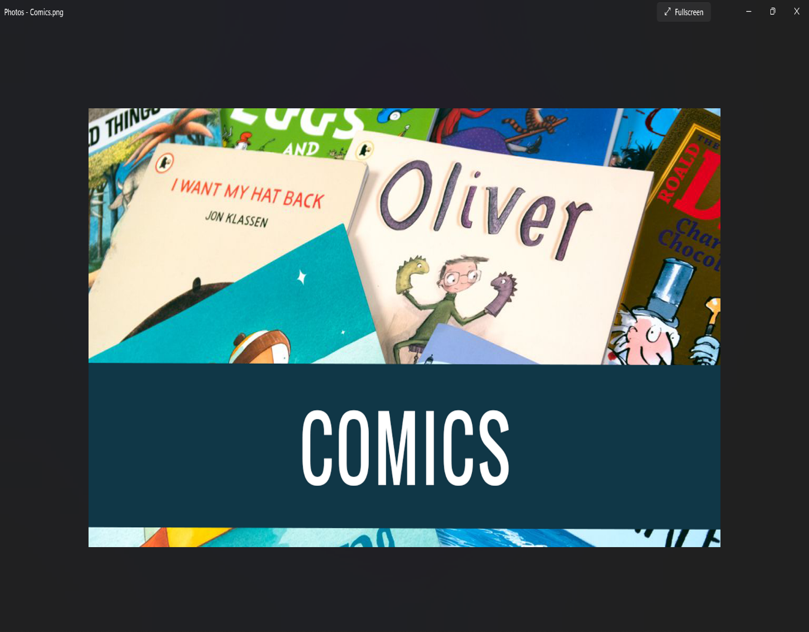

Figure 4.2.2 – The Target Image for the Category under Comics

**4.3 DATA FLOW DIAGRAM**

Data flow diagrams are used to graphically represent the flow of data in a business information system. DFD describes the processes that are involved in a system to transfer data from the input to the file storage and reports generation.

Data flow diagrams can be divided into logical and physical. The logical data flow diagram describes flow of data through a system to perform certain functionality of a business. The physical data flow diagram describes the implementation of the logical data flow.

LEVEL 0

Figure 4.3.1 – Level 0 Data Flow Diagram

LEVEL 1

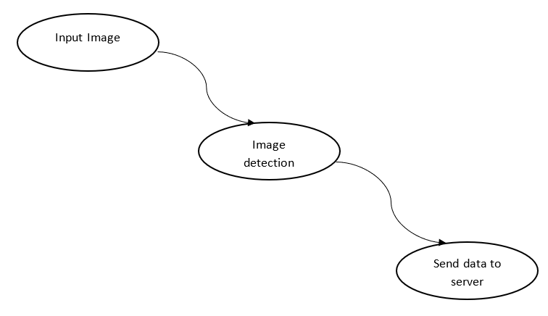

Figure 4.3.2 – Level 1 Data Flow Diagram

LEVEL 2

Figure 4.3.3 – Level 2 Data Flow Diagram

**4.4 UML DIAGRAMS**

**I)USE CASE DIAGRAM**

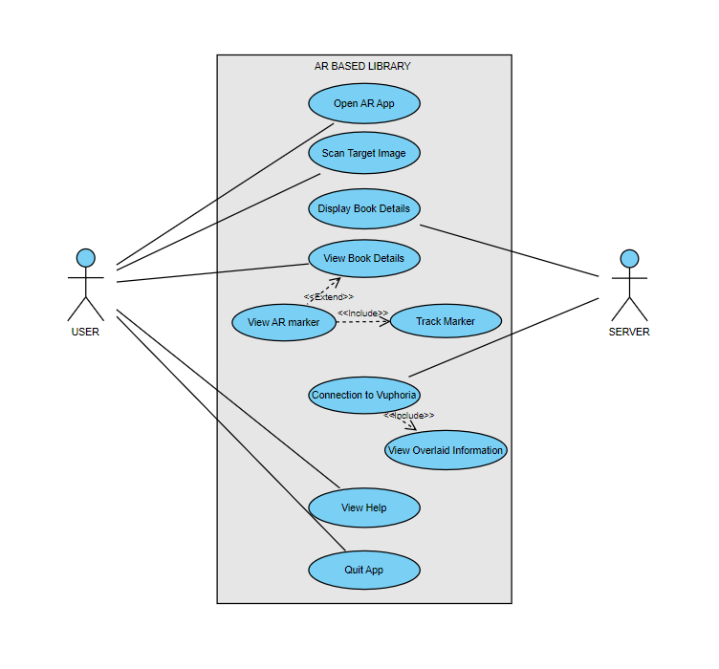

Figure 4.4.1 – Use Case Diagram of AR Library Project

**II)CLASS DIAGRAM**

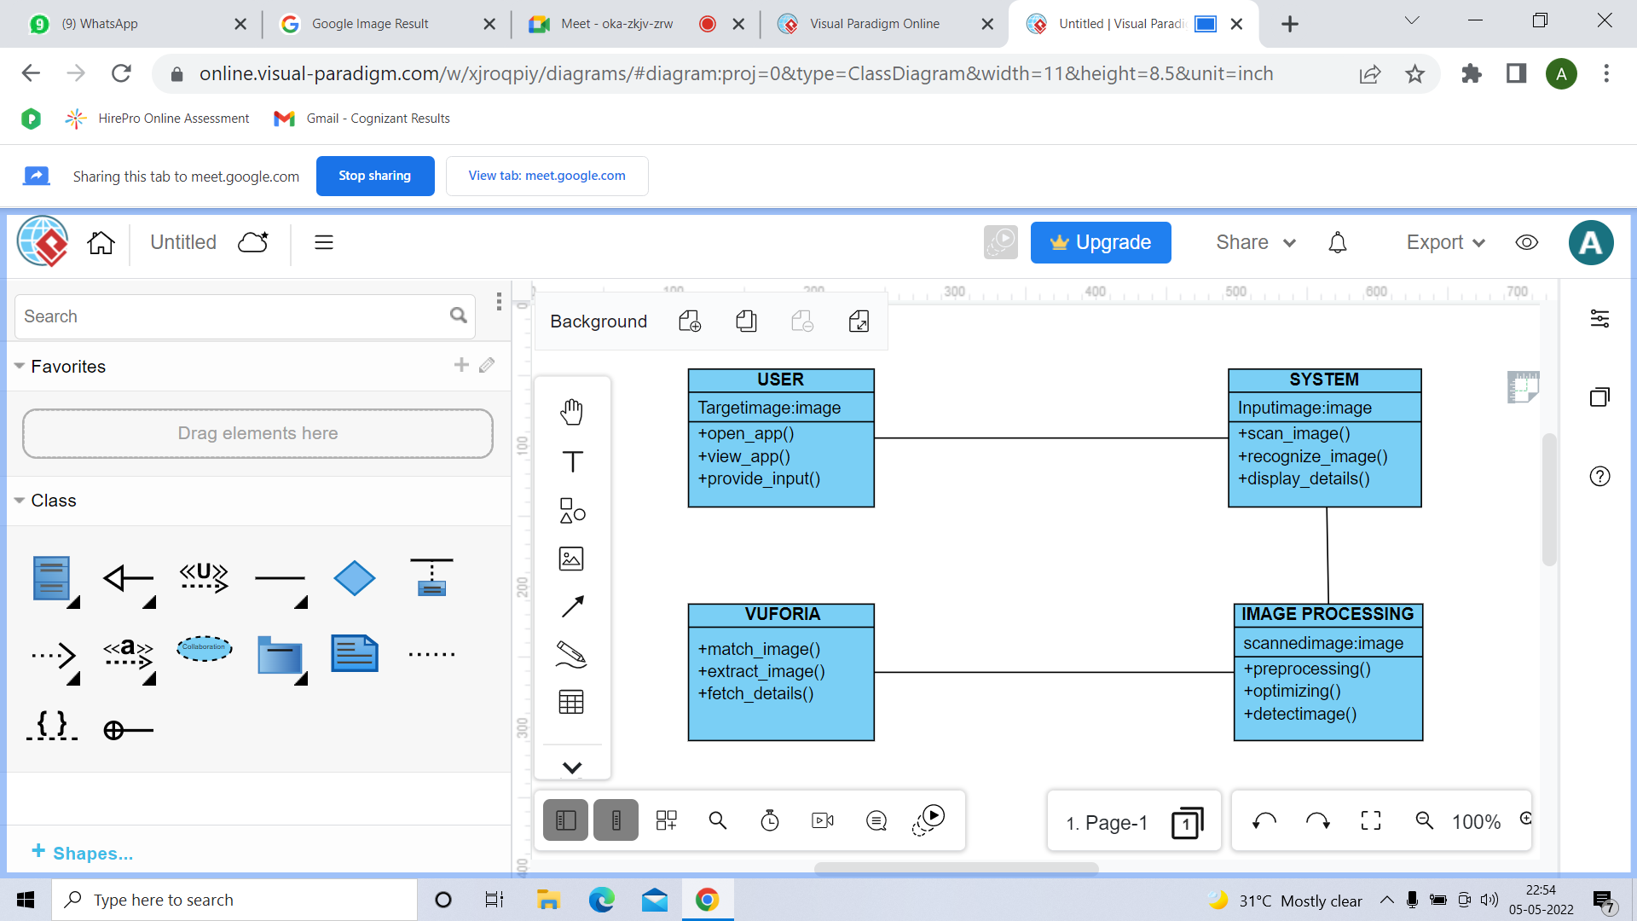

Figure 4.4.2 – Class Diagram of AR Library Project

**III)ACTIVITY DIAGRAM**

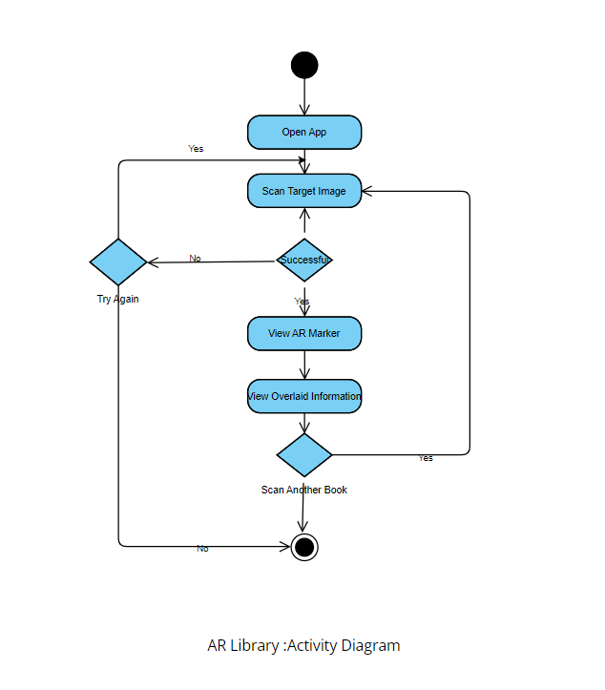

Figure 4.4.3 – Activity Diagram of AR Library Project

**IV)SEQUENCE DIAGRAM**



Figure 4.4.4 – Class Diagram of AR Library Project

**V)DEPLOYMENT DIAGRAM**

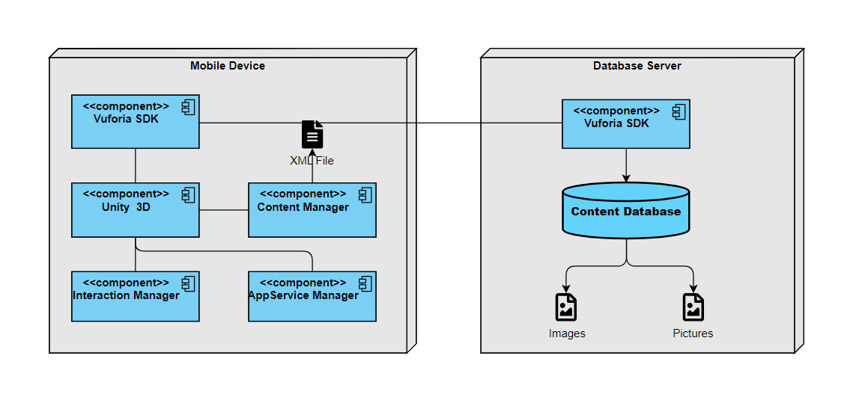

Figure 4.4.5 – Deployment Diagram of AR Library Project

**VI)STATE CHART DIAGRAM**

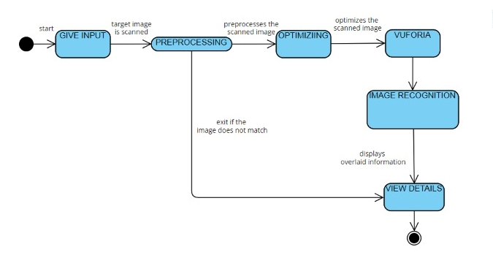

Figure 4.4.6 – State Chart Diagram of AR Library Project

**CHAPTER 5**

**SYSTEM ARCHITECTURE**

**ARCHITECTURE DIAGRAM**

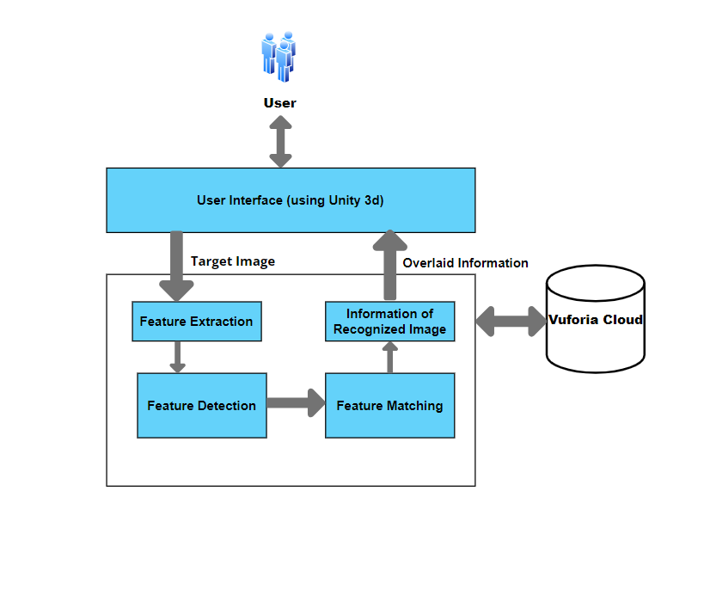**Figure 5.1.1 - System Architecture Diagram**

**5.1 MODULE DESIGN SPECIFICATION**

* Unity 3D
* Android Studio
* Vuforia
* Image Processing

**MODULE DESCRIPTION**

**5.1.1 UNITY 3D**

* Unity is currently the most popular gaming engine used by developers around the world - and for good reason. It has a powerful visual interface for making games, cross platform development, and an active contributing community.
* Unity is a cross-platform game engine primarily used to develop video games and simulations for PC, consoles, mobile devices and websites
* the window of Unity 3D is made up of small individual windows that can be rearranged, grouped in sets, detached from one position and docked back again, within the main window
* “ARCamera” is an Augmented Reality camera prefab from Vuforia. Image Target is added to the scene. Fig. 4.2.1 shows the Image Target that is added into Unity which is obtained by importing the dataset downloaded from Vuforia.

**5.1.2 ANDRIOD STUDIO**

* Android Studio is the officialintegrated development environment (IDE) for Google's Android operating system, built on JetBrains' IntelliJ IDEA software and designed specifically for Android development.
* Android Studio supports all the same programming languages of IntelliJ (and CLion) e.g. Java, C++, and more with extensions, such as Go.

**5.1.3 VUFORIA**

* Vuforia is an augmented reality software development kit (SDK) for mobile devices that enables the creation of augmented reality applications.
* To get started, Vuforia’s Developer Portal is set up, and an account is created. Once logged in, a developer page is available. A license key works as an ID to create an application in Unity using Vuforia.
* This license key is created in the developer page with the help of a “License Manager”. Next, the “Target Manager” is used to add Image Target in Unity. This is done by adding an Image Target database and filling in the details.
* Images are added to the newly made database. Vuforia supports various kinds of targets like a single flat image, cylindrical, cuboidal, 3D image, etc. Lastly, this Image target database is downloaded for importing into Unity. This is done with the help of the “Download Dataset”.

**5.1.4 IMAGE PROCESSING**

We are using Marker Recognizing for Image Processing.

**MARKER RECOGNITION**

Marker is an image (it could be anything) that can be uniquely identified and not be confused with other image as it will be the gateway through which virtual elements can be brought into the real world. The application is programmed to recognize the marker in an arbitrary scene and give details of its locations and orientation. To recognize a marker, the following steps are followed:

* Input
* Grayscale Conversion
* Thresholding

**5.2 ALGORITHM**

**5.2.1 IMAGE RECOGNITION**

The software must derive real world coordinates, independent of camera, and camera images. That process is called [image recognition](https://en.wikipedia.org/wiki/Image_registration), and uses different methods of [computer vision](https://en.wikipedia.org/wiki/Computer_vision), mostly related to [video tracking](https://en.wikipedia.org/wiki/Video_tracking). Markers are visual cues which trigger the display of the virtual information. A piece of paper with some distinct geometries can be used. The camera recognizes the geometries by identifying specific points in the drawing.

**5.2.2 FEATURE EXTRACTION**

It consists of two parts. The first stage is to detect [interest points](https://en.wikipedia.org/wiki/Interest_point_detection), fiducial markers or [optical flow](https://en.wikipedia.org/wiki/Optical_flow) in the camera images. This step can use [feature detection](https://en.wikipedia.org/wiki/Feature_detection_(computer_vision)) methods like [corner detection](https://en.wikipedia.org/wiki/Corner_detection), [blob detection](https://en.wikipedia.org/wiki/Blob_detection), [edge detection](https://en.wikipedia.org/wiki/Edge_detection) or [thresholding](https://en.wikipedia.org/wiki/Thresholding_(image_processing)), and other [image processing](https://en.wikipedia.org/wiki/Image_processing) methods. The second stage restores a real-world coordinate system from the data obtained in the first stage. Some methods assume objects with known geometry (or fiducial markers) are present in the scene. In some of those cases the scene 3D structure should be calculated beforehand. If part of the scene is unknown simultaneous localization and mapping (SLAM) can map relative positions. If no information about scene geometry is available, [structure from motion](https://en.wikipedia.org/wiki/Structure_from_motion) methods like [bundle adjustment](https://en.wikipedia.org/wiki/Bundle_adjustment) are used. Mathematical methods used in the second stage include: [projective](https://en.wikipedia.org/wiki/Projective_geometry) ([epipolar](https://en.wikipedia.org/wiki/Epipolar_geometry)) geometry, [geometric algebra](https://en.wikipedia.org/wiki/Geometric_algebra), rotation representation with [exponential map](https://en.wikipedia.org/wiki/Rotation_matrix#Exponential_map), [Kalman](https://en.wikipedia.org/wiki/Kalman_filter) and [particle](https://en.wikipedia.org/wiki/Particle_filter) filters, [nonlinear optimization](https://en.wikipedia.org/wiki/Nonlinear_optimization), [robust statistics](https://en.wikipedia.org/wiki/Robust_statistics).

To recognize a marker, the following steps are followed:

**1. Input:** The image is captured using the onboard camera or the camera connected to the system. It can be either captured as live still image or as a video, preferably a video is used and the input is then send for processing further down the steps.

**2. Grayscale Conversion:** The input frame is done in the intensity plane and then converted to the grayscale. Input of an android phone is given in RGB format and so it is converted into grayscale.

**3. Thresholding:** After this the image is converted into binary image so that a binary image component analysis can be performed. Two types of threshold is used for the conversion: Adaptive Threshold and Global Threshold

**CHAPTER 6**

**SYSTEM**

**IMPLEMENTATION**

**6.1 CLIENT-SIDE CODING**

using System.Collections;

using System.Collections.Generic;

using UnityEngine;

public class arui : MonoBehaviour

{

public GameObject Panel;

public void OpenPanel()

{

if(Panel !=null)

{

bool isActive = Panel.activeSelf;

Panel.SetActive(!isActive);

}

}

}

**6.2.1 JSON MANIFEST**

{

"dependencies": {

"com.ptc.vuforia.engine": "8.1.12",

"com.unity.collab-proxy": "1.2.16",

"com.unity.ide.rider": "1.1.4",

"com.unity.ide.vscode": "1.2.3",

"com.unity.test-framework": "1.1.19",

"com.unity.textmeshpro": "2.1.1",

"com.unity.timeline": "1.2.17",

"com.unity.ugui": "1.0.0",

"com.unity.modules.ai": "1.0.0",

"com.unity.modules.androidjni": "1.0.0",

"com.unity.modules.animation": "1.0.0",

"com.unity.modules.assetbundle": "1.0.0",

"com.unity.modules.audio": "1.0.0",

"com.unity.modules.cloth": "1.0.0",

"com.unity.modules.director": "1.0.0",

"com.unity.modules.imageconversion": "1.0.0",

"com.unity.modules.imgui": "1.0.0",

"com.unity.modules.jsonserialize": "1.0.0",

"com.unity.modules.particlesystem": "1.0.0",

"com.unity.modules.physics": "1.0.0",

"com.unity.modules.physics2d": "1.0.0",

"com.unity.modules.screencapture": "1.0.0",

"com.unity.modules.terrain": "1.0.0",

"com.unity.modules.terrainphysics": "1.0.0",

"com.unity.modules.tilemap": "1.0.0",

"com.unity.modules.ui": "1.0.0",

"com.unity.modules.uielements": "1.0.0",

"com.unity.modules.umbra": "1.0.0",

"com.unity.modules.unityanalytics": "1.0.0",

"com.unity.modules.unitywebrequest": "1.0.0",

"com.unity.modules.unitywebrequestassetbundle": "1.0.0",

"com.unity.modules.unitywebrequestaudio": "1.0.0",

"com.unity.modules.unitywebrequesttexture": "1.0.0",

"com.unity.modules.unitywebrequestwww": "1.0.0",

"com.unity.modules.vehicles": "1.0.0",

"com.unity.modules.video": "1.0.0",

"com.unity.modules.vr": "1.0.0",

"com.unity.modules.wind": "1.0.0",

"com.unity.modules.xr": "1.0.0"

}

}

**6.2.2 JSON PACKAGES-LOCK**

{

"dependencies": {

"com.ptc.vuforia.engine": {

"version": "8.1.12",

"depth": 0,

"source": "registry",

"dependencies": {

"com.unity.ugui": "1.0.0"

},

"url": "https://packages.unity.com"

},

"com.unity.collab-proxy": {

"version": "1.2.16",

"depth": 0,

"source": "registry",

"dependencies": {},

"url": "https://packages.unity.com"

},

"com.unity.ext.nunit": {

"version": "1.0.5",

"depth": 1,

"source": "registry",

"dependencies": {},

"url": "https://packages.unity.com"

},

"com.unity.ide.rider": {

"version": "1.1.4",

"depth": 0,

"source": "registry",

"dependencies": {

"com.unity.test-framework": "1.1.1"

},

"url": "https://packages.unity.com"

},

"com.unity.ide.vscode": {

"version": "1.2.3",

"depth": 0,

"source": "registry",

"dependencies": {},

"url": "https://packages.unity.com"

},

"com.unity.test-framework": {

"version": "1.1.19",

"depth": 0,

"source": "registry",

"dependencies": {

"com.unity.ext.nunit": "1.0.5",

"com.unity.modules.imgui": "1.0.0",

"com.unity.modules.jsonserialize": "1.0.0"

},

"url": "https://packages.unity.com"

},

"com.unity.textmeshpro": {

"version": "2.1.1",

"depth": 0,

"source": "registry",

"dependencies": {

"com.unity.ugui": "1.0.0"

},

"url": "https://packages.unity.com"

},

"com.unity.timeline": {

"version": "1.2.17",

"depth": 0,

"source": "registry",

"dependencies": {},

"url": "https://packages.unity.com"

},

"com.unity.ugui": {

"version": "1.0.0",

"depth": 0,

"source": "builtin",

"dependencies": {

"com.unity.modules.ui": "1.0.0",

"com.unity.modules.imgui": "1.0.0"

}

},

"com.unity.modules.ai": {

"version": "1.0.0",

"depth": 0,

"source": "builtin",

"dependencies": {}

},

"com.unity.modules.androidjni": {

"version": "1.0.0",

"depth": 0,

"source": "builtin",

"dependencies": {}

},

"com.unity.modules.animation": {

"version": "1.0.0",

"depth": 0,

"source": "builtin",

"dependencies": {}

},

"com.unity.modules.assetbundle": {

"version": "1.0.0",

"depth": 0,

"source": "builtin",

"dependencies": {}

},

"com.unity.modules.audio": {

"version": "1.0.0",

"depth": 0,

"source": "builtin",

"dependencies": {}

},

"com.unity.modules.cloth": {

"version": "1.0.0",

"depth": 0,

"source": "builtin",

"dependencies": {

"com.unity.modules.physics": "1.0.0"

}

},

"com.unity.modules.director": {

"version": "1.0.0",

"depth": 0,

"source": "builtin",

"dependencies": {

"com.unity.modules.audio": "1.0.0",

"com.unity.modules.animation": "1.0.0"

}

**CHAPTER 7**

**SYSTEM TESTING**

**7.1 RESULTS AND DISCUSSION**

**RESULT**: This paper proposes a method to digitize the library and makes an interaction library system with the customers. This project makes finding of the books easier compared to the conventional one. Augmented Reality increases the utilization of the application with attractive appearance. The objective of the project was successfully implemented.

**DISCUSSION:** Offering interesting, useful, user-friendly and engaging services to library visitors is a bet that every library should win. Libraries should be open-minded to adopt new technologies like AR and adapt them to the special characteristics a library environment demonstrates. Moreover, a modern library digital system should incorporate social networking capabilities which will disseminate effectively the library’s services to the broad public through the social activities of the library visitors. We propose Active Visitor, a system that provide interactive AR and social services to library visitors. In particular, the proposed system allows users to use their mobile devices and see overlaid information above the Target Poster. Users can view in the camera view of their mobile device.

**7.2 SYSTEM TESTING**

The purpose of testing is to discover errors. Testing is the process of trying to discover every conceivable fault or weakness in a work product. It provides a way to check the functionality of components, sub-assemblies, assemblies and/or a finished product It is the process of exercising software with the intent of ensuring that the

Software system meets its requirements and user expectations and does not fail in an unacceptable manner. There are various types of test. Each test type addresses a specific testing requirement.

**7.2.1 UNIT TESTING**

Unit testing involves the design of test cases that validate that the internal program logic is functioning properly, and that program inputs produce valid outputs. All decision branches and internal code flow should be validated. It is the testing of individual software units of the application .it is done after the completion of an individual unit before integration. This is a structural testing, that relies on knowledge of its construction and is invasive. Unit tests perform basic tests at component level and test a specific business process, application, and/or system configuration. Unit tests ensure that each unique path of a business process performs accurately to the documented specifications and contains clearly defined inputs and expected results.

**7.2.2 INTEGRATION TESTING**

Integration tests are designed to test integrated software components to determine if they actually run as one program. Testing is event driven and is more concerned with the basic outcome of screens or fields. Integration tests demonstrate that although the components were individually satisfaction, as shown by successfully unit testing, the combination of components is correct and consistent. Integration testing is specifically aimed at exposing the problems that arise from the combination of components.

**7.2.3 TEST CASES**

|  |  |  |  |  |
| --- | --- | --- | --- | --- |
| **S.NO** | **SCENARIO** | **INPUT** | **EXPECTED**  **OUTPUT** | **ACTUAL OUTPUT** |
| 1 | Add Target Image | Admin adds Target Image to Vuforia Cloud. | Admin adds target Image if Rating is above three ”Successfully added” or “Unsuccessful”. | Required five star rating for uploading target image. |
| 2 | Open ARLib App and Scan | User Open’s the app and scan the Target Image. | If the Feature is extracted and then Feature Detection is “Successful” or “Unsuccessful” | Scanned and detected successfully or it’s  not vaild. |
| 3 | Image Processing | If the Feature is Detected Feature Matching is proceeded. | If Feature is Matched Properly List Of Books will be Augmented “Successfully” or it’s “Unsuccessful”. | Target Image Recognized and Matched successfully or  Unsuccessful. |
| 4 | Book Description and Location | If the Books are Listed the books details can be viewed. | If the Book Title is clicked the book detail, description and location is displayed “Successfully” or it’s “Unsuccessful”. | Select a book from list of books and it displays the book details if it’s successfully or it is  Unsuccessful. |

**CHAPTER 8**

**CONCLUSION**

**8.1 CONCLUSION AND FUTURE ENHANCEMENT**

**CONCLUSION:** The system “Implementation of real time image processing in augmented reality” is implemented where a user can hover a camera over a page and obtain augmented information such as book details, or an explanation about that page. It is a system where no typing or searching is required for getting information. Since the application can be deployed on any smartphone, a student can use it as per his/her convenience. Also, there is no need of any extra maintenance for this application thus making it an economical solution. The interactivity aspect of this application like showing the overlaid information allows the user to understand the concept from every angle.

**FUTURE ENHANCEMENT:** The application can be expanded further and used for various age groups for not only learning but also helping the users to visualize and grasp things faster. It provides a unique and interesting way of learning and understanding of unknown concepts.

For our next steps, we can add IR Sensors to detect the presence of book and to show its details respectively. Also, we may add direction symbols to locate the book. Furthermore, we can seek to use and evaluate the proposed system through AR glasses. As wearable AR technology evolves every day, AR glasses are expected to further revolutionize AR technology and lead to mass usability.

**APPENDICES**

**8.1 SAMPLE SCREEN SHOTS**

**SAMPLE TARGET IMAGES**



Figure 8.1.1 – Target Image of the Category Under Fiction



Figure 8.1.2 - Target Image of the Category Under Comics

**SAMPLE INPUT AND OUTPUT SCREEN SHOTS**

After scanning the target Image we get Overlaid Information using the mobile device over the Real Image.

**GENERE 1**

Figure 8.1.3 -List of Books shown after scanning the target image



Figure 8.1.4 – Details of the book which has been selected is displayed

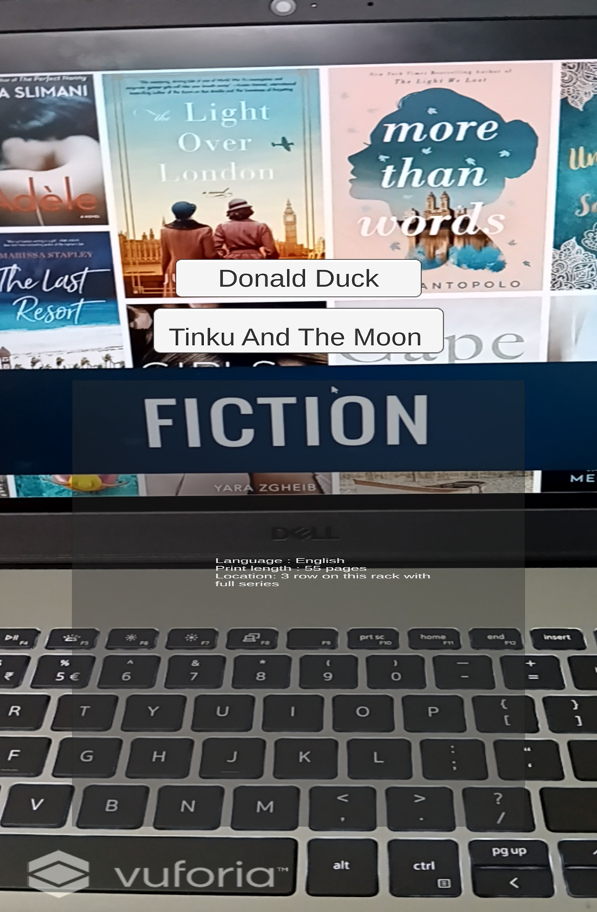

Figure 8.1.5– Details of the book which has been selected is displayed

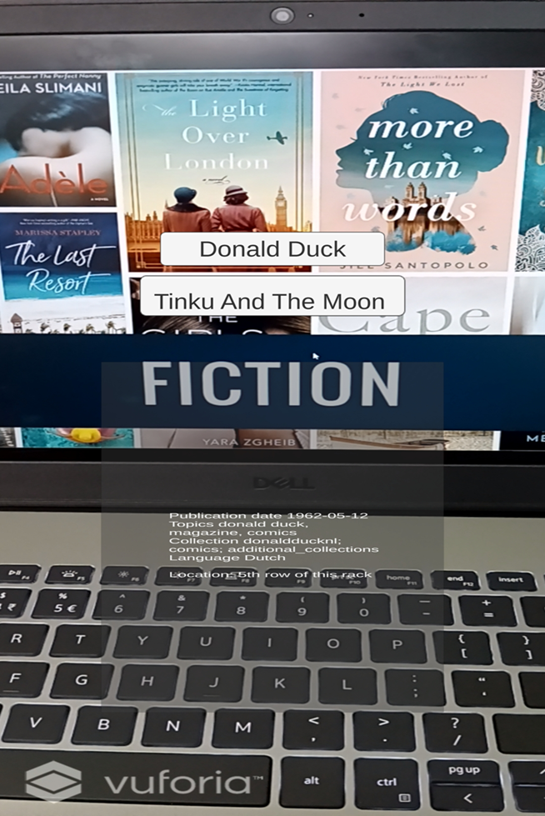

**GENERE 2**

Figure 8.1.6 -List of Books shown after scanning the target image



Figure 8.1.7 - Details of the book which has been selected is displayed

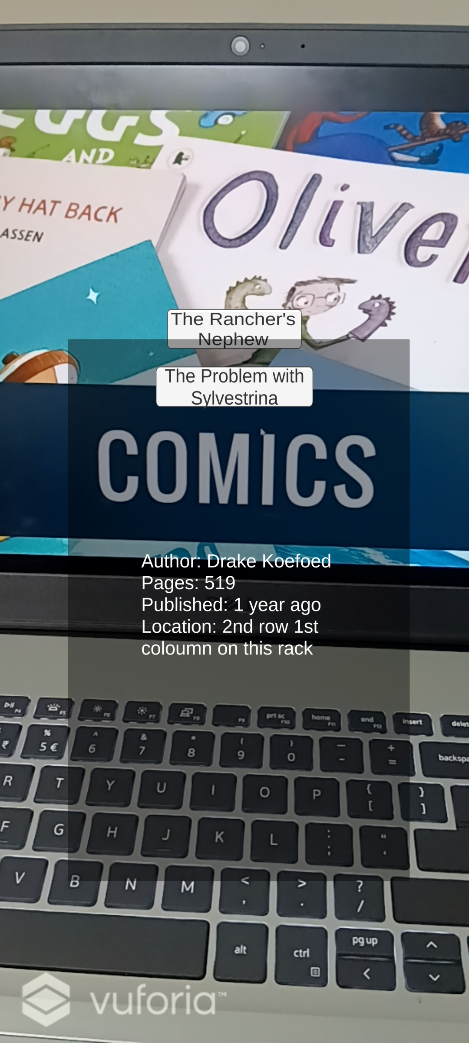

Figure 8.1.8 - Details of the book which has been selected is displayed

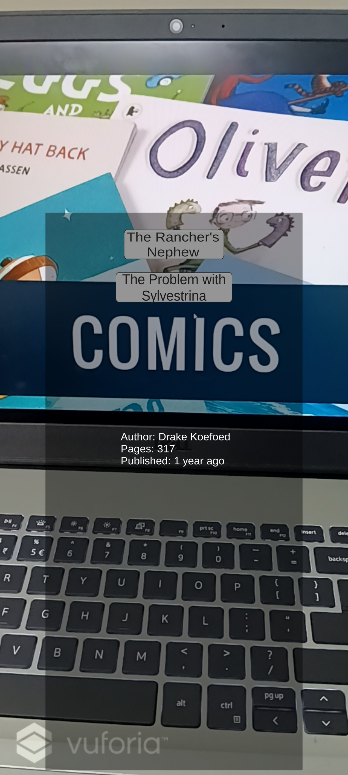

**REFERENCES**

[1] A. Syberfeldt, O. Danielsson, and P. Gustavsson, ‘‘Augmented reality smart glasses in the smart factory: Product evaluation guidelines and review of available products,’’ IEEE Access, vol. 5, pp. 9118–9130, 2017.

[2] X. Qiao, P. Ren, S. Dustdar, and J. Chen, ‘‘A new era for Web AR with mobile edge computing,’’ IEEE Internet Comput., vol. 22, no. 4, pp. 46–55, Jul. 2018.

[3] M. Makar, V. Chandrasekhar, S. S. Tsai, D. Chen, and B. Girod, ‘‘Interframe coding of feature descriptors for mobile augmented reality,’’ IEEE Trans. Image Process., vol. 23, no. 8, pp. 3352–3367, Aug. 2014.

[4] T. Engelke, M. Becker, H. Wuest, J. Keil, and A. Kuijper, ‘‘MobileAR browser—A generic architecture for rapid AR-multi-level development,’’ Expert Syst. Appl., vol. 40, no. 7, pp. 2704–2714, Jun. 2013.

[5] D. Chatzopoulos, C. Bermejo, Z. Huang, and P. Hui, ‘‘Mobile augmented reality survey: From where we are to where we go,’’ IEEE Access, vol. 5, pp. 6917–6950, 2017.

[6] Udaya Dampage, D.A.Egodagamage “Spatial Augmented Reality Based Customer Satisfaction Enhancement and Monitoring System”,IEEE Access, vol. 9, pp. 97990,2021.

[7] Ali Arya, Robert J. Teather “Virtual reality and augmented reality in social learning spaces: a literature review” , Springer 2020.

[8] Liang Li , Xiuquan Qiao , Pei Ren “Rendering Optimization for Mobile Web 3D Based on Animation Data Separation and On-Demand Loading”, IEEE Access, vol. 8 ,pp. 88474,2020.

[9] Shabnam Shahreen Sifat and Ali Shihab Sabbir “3D model interaction”, ,2019.

[10] Zois Koukopoulos, Dimitrios Koukopoulos “Active Visitor: Augmenting Libraries into Social Spaces”, IEEE Xplore,2019.

[11] Yongjun Qiao , Xiaofang Xie , “Tao Sun A Mobile Intelligent Training System for ATM”, 2018.

[12] Dimitris Chatzopoulos, Carlos Bermejo, Zhanpeng Huang, And Pan Hui

“Mobile Augmented Reality Survey: From Where We Are to Where We Go”, IEEE ACCESS , vol 5, pp.6917 ,2017.

[13] Albert A Cervera-Uribe ”The Augmented Library: An Approach for Improving Users Awareness in a Campus Library”, IEEE Computer Society, 2017.